
BULLETIN – Day 3
Microfinance and Inclusive Development
An Alternative Summit
June 21-23, 2011, Hyderabad, INDIA

Financial inclusion is beyond microfinance


Smt. Usha Thorat
Director, Centre for Advanced Financial Research, and Learning
Reserve Bank of India
I thank INAFI for inviting me here today for the concluding function of the Summit. I am sure you have gained tremendously from the interactions that you have had with similar organisations within and outside India. Financial inclusion has become a global buzzword and is even on the G20 agenda. But that is a recent phenomenon while you have been working in this area for a long time. There has been a surge of ‘for profit’ micro finance companies in the recent past especially in this State. Based on this experience and the experience of “not for profit” form of organisations like cooperatives, SHGs, trusts and societies, I am sure there has been a healthy discussion of the pros and cons and how to get the best of both worlds.
When we look at the number of people without access to mainstream formal payments and financial services, it is apparent that the need of the hour is to scale–up. At the same time, past experience shows that scaling–up, unmindful of the needs or capacity of the household to assume this increased debt and the need to have systems within the lending agency to manage the scaled up numbers, can jeopardise the household as well as the provider of financial services. The experience in microfinance shows that there is an urgent need to sensitise employees of financial service providers to safeguard the interests of the poor with utmost integrity thereby expanding the social capital for the provider as well as expanding the trust amongst the customers.
I would like to address some issues relating to financial inclusion that are relevant in this background. Firstly, are we right in pushing commercial banks as the principal player in ensuring financial inclusion and providing a universally accessible national payments system? What is and could be the role of cooperative banks –rural and urban, regional rural banks and non banking financial institutions both for profit and not for profit? What is the role of the non-banks? What are the synergies between banks and non-banks in this context? Banks have the financial clout and the technology; non-banks have the innovativeness, the local knowledge and the last mile access. How do we mesh these two for optimising the results and achieve the objectives? What can be the various forms of partnerships between non-bank financial institutions and banks? What can be the kinds of partnerships banks and non-bank non-financial entities?
Microfinance is not financial inclusion –the latter goes much beyond micro finance. It means access to a bank account which has links to the mainstream payments system and deposit insurance. Both these are important for all citizens and especially the low income households.
Secondly, the need to create an effective and inclusive payments system that protects privacy of the consumers while concurrently enabling convenience. The Government has a huge stake in having a ubiquitous inter-operable electronic payments system that could be used seamlessly for making all government payments.
The third issue I would like to raise is that of multiple lending and over lending. This requires a comprehensive credit information system where it is possible for lenders to electronically and instantaneously check the credit record of the borrower. Such a record should cover all types of payments including public utility bills. This will ensure that a conducive credit culture is developed – this is vitally needed for sustainable financial sector development.
Fourthly, it is important to redefine the manner in which one approaches the issue of risk among low-income households. Having said that reliable credit records are very important in facilitating credit flow, it is equally important to have a system to deal with adversity and natural calamities that can destroy low income household’s ability to service the debt contracted by them. In addition, there is need for providing such households credit for housing and education apart from financing their livelihood or business. Health hazards, accidents and premature deaths have the potential to lead to defaults. Hence, for effective financial inclusion, a combination of financial products incorporating savings, pensions, health, crop/weather, life and accident insurance apart from a loan product is the need of the hour.
Fifthly and this is closely related to the issue of risk, is the title to property. This issue gets often ignored when we talk of collateral free loans. Many sharecroppers, marginal farmers and informal settlers in urban areas are unable to offer as security the land /property they occupy and whose usufruct they enjoy. This impedes the flow of formal sector credit to such borrowers. Hence there is a need to regularise the title to such properties –if not the title then at least some sort of recognition for their occupancy could be considered to enable them to get banks loans
Sixthly, recovery and credit discipline is important in creating a repayment culture and infusing confidence amongst lenders which alone can facilitate greater inclusion. While most States have enacted a law to simplify the procedure for recovery of loans to priority sector, the implementation leaves a lot to be desired. Ultimately the knowledge that fresh loans will not be forthcoming until the earlier loans are repaid is the best deterrent. NGOs can play a useful role in sensitising the need for borrowing within means, making the correct financial choices for the family and making regular repayments of loans taken. NGOs could help by helping increase awareness about the mutually beneficial relationship that would accrue if the banks and the people were willing to understand each other better.
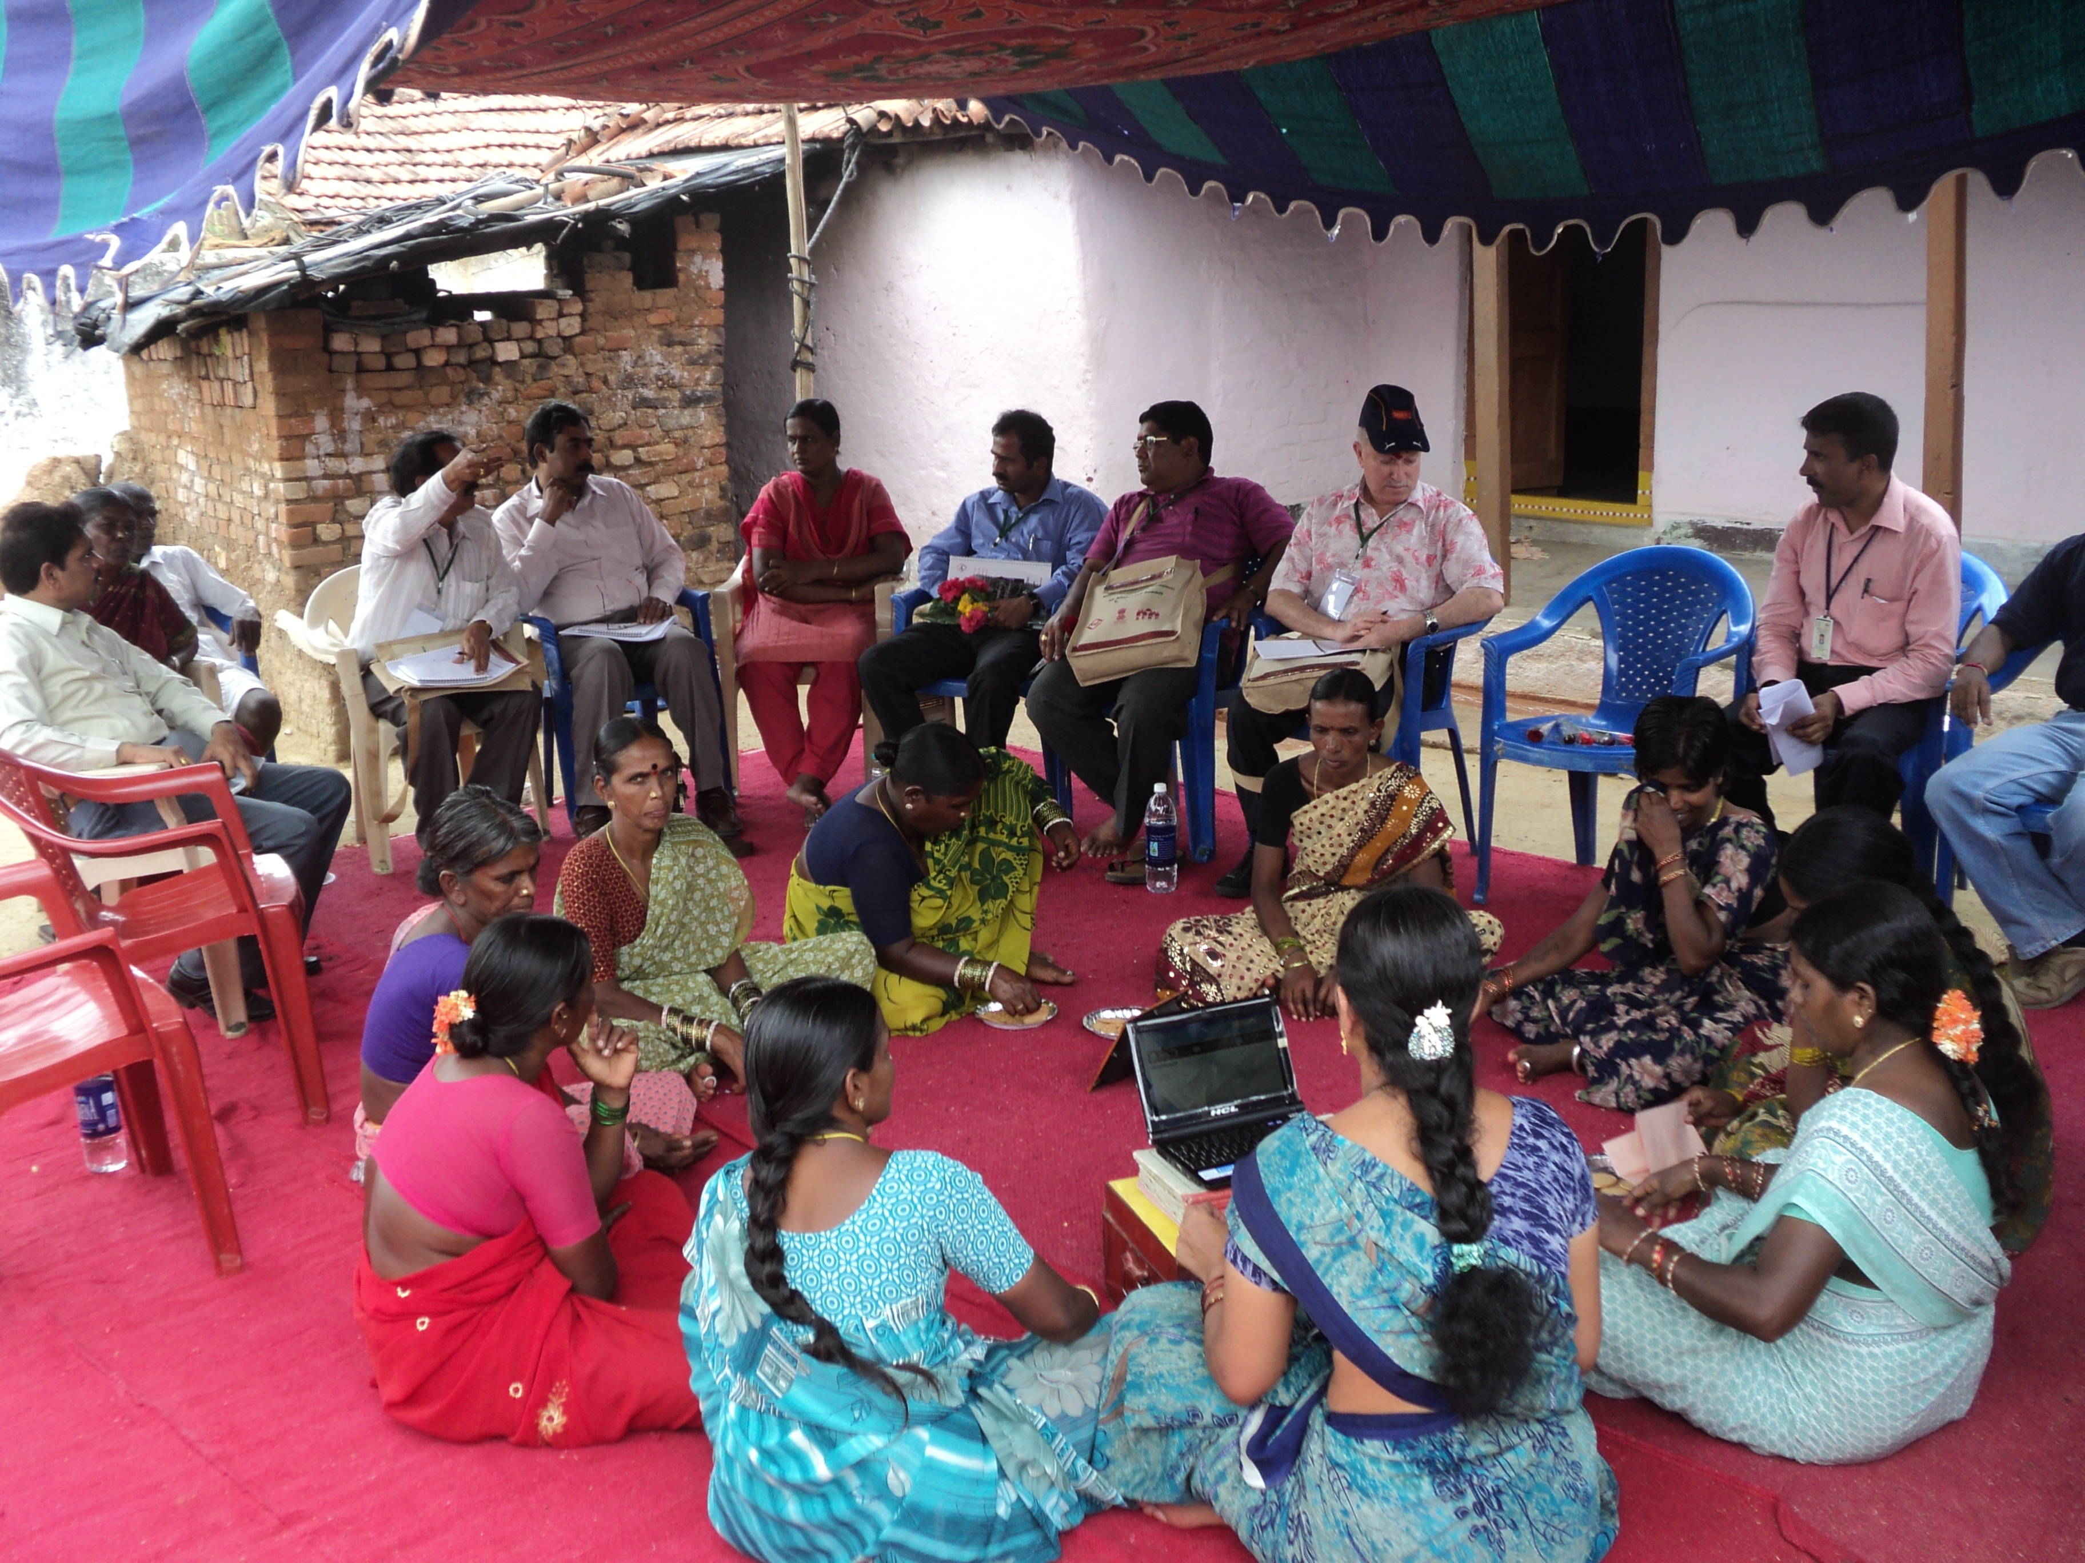
Seventh is the need for financial literacy and financial counselling. Both from the lenders and borrowers perspective this is very important. There is a very large stake for all concerned- the government, the regulators, the financial services providers and the customer and the NGOs. The initiative can be taken by anybody but all should join in the efforts.
Finally, I want to touch upon the sensitive issue of interest rates. A lot has been said about the return covering all costs including cost of capital, cost of funds, risk premium and transaction cost. It is also acknowledged that the transaction cost for a loan of Rs 10000 is double that for a loan of Rs 20,000. The interest rates for SHG members are set by the group and are not regulated. Generally the rates would vary from 25 to 30 per cent. Following Malegam committee recommendations, the maximum rate of interest that MFIs can charge has been set at 26 per cent. In 2010, RBI deregulated interest rates on priority sector loans. Banks can actually lend at much lower rates than SHGs or MFIs as their cost of funds is lower and they can reduce the transaction costs by using BCs.
To conclude, it is important to recognise that financial inclusion goes beyond micro finance. It means access to bank accounts, payments system and deposit insurance, in addition to access to savings, insurance, loans and capital market products. As part of the eco–system in providng an enabling environment for effective financial inclusion , I have stressed upon the relationship and partnerships between banks and non banks for ensuring efficient delivery mechanism especially for providing access to deposit insurance, the role of an ubiquitous interoperable payments system, the need for effective credit information system , conducive credit culture, financial literacy and counseling and finally the issue of reasonable interest rates that provide banks with a business model while ensuring quick and hassle free availability. There is a very important role for NGOs and community based orgainsations such as yours in this national endeavour and I wish you all the best.
Field Visit Observations

The participants were made into 16 sub groups and taken to the villages, where the Society for Elimination of Rural Poverty is implementing SHG Programme. They interacted with the SHG women and shared their experiences in the plenary session.

Appreciations
- The SERP has created a huge amount of social capital and the SHGs have naturally integrated into government system.
- A replicable model for poverty reduction has been created
- Leadership building in the SHGs has been enormous and there is a systematic rotation of leadership once in a year to provide equal leadership opportunity to all the members.
- Commodity procurement and marketing of milk, paddy, maize and wheat has in deed paid results in terms of changed economic profile of the area and enhanced income of the producers
- The SERP has been endowed with a committed manpower at all levels.

Comments / Suggestions
- The informal leadership has been built at the SHG level, how are these leaders going to engage with existing power structures
- The sustainability of poverty reduction initiatives needs to be looked at in the event of new government and lack of subsidized funding
- There is a need for integrating the SHGs, Village Organisations, Mandak Samakhyas with the formal Panchayat systems to mainstream and sustain the initiatives
- Inclusion of extremely vulnerable groups into the SHG system needs to be looked at. The affluent population, who as part of the SHGs need to be treated separately and the equity of development needs to be ensured.
- Savings in the SHGs shall be given high priority.
Parallel Sessions

Development Credit
- Credit policy at the SHG level should be based on need and credit absorption capacity of members and should be facilitated by NGOs, bankers, and other stakeholders. Adequacy, timeliness, affordability, hassle free processes, and repeat support are critical components of poverty lending.
- Credit alone is not enough for getting members out of poverty. An integrated approach and other support services are required.
- Organising producer collectives and moving up value chain for increasing incomes of producers, credit and insurance products suiting the needs of producers and producer companies need to be innovated involving other stakeholders.

Microfinance and Natural Resource Development
- Microfinance can be used as a tool to organize the community for natural resource management especially in rehabilitating and maintaining traditional water harvesting structures such as Rivers, Ponds, Canals, Surface water and open water bodies. The short-term benefits of the water resources development include addressing the immediate water crisis faced by both humans and livestock – ensuring availability of clean drinking water. The long term impact includes greater drought preparedness of the village community.
- Timely and enhanced credit availability to the microfinance groups of farmers for the agriculture and allied activities, context specific repayment schedule (like one time payment at the time of harvest in tribal area) are very critical for sustaining farmers’ livelihoods.

Microfinance and Financial Inclusion
- Financial inclusion among urban poor is the need of the hour. Constrained by the bank’s KYC norms they are largely excluded from the banking system. Organsising them into SHGs and linkages with banks could be a solution for making them financially included.
- The BC/BF models envisaged for financial inclusion by the commercial banks shall have flexibility in collection of the fees on realistic basis, creation of special fund for capacity building and incentive for working in the underserved areas.

Consumer Protection
- Code of conduct should be evolved for the MFIs and enforced with stringent norms. The Code of Conduct could be in the areas such as transparent processing and documentation, recovery approach, governance of MFIs, grievance redress mechanisms, etc.
- Suitable consumer protection mechanisms should be created in SHGs with risk sharing, insurance, interest subsidies. Financial counseling could be a mechanism to educate the members on when to borrow, how much to borrow, cash flow management within the households etc.

Microfinance and ICT
- Leveraging benefits of ICT to the microfinance operations at SHG level need public investment. Mobilizing support through the Corporate Social Responsibility could be one of the ways.
- Client based and location specific customized software would reduce the drudgery of book keeping and maintenance of accounts / management information system for efficient microfinance operations.

Microfinance and Remittances
- As most of the microfinance clients are from the rural areas, most of the remittances go to there, which makes the role of microfinance programmes to be responsive to the needs of the members. Post remittance services are very important
- Change in perspectives of migrants on their finance and its management is very critical. Financial counseling for setting goals, capacity building in managing finance and monitoring expenses, increase savings connected with insurance are some of the strategies to facilitate remittances.

Microfinance and Health Programmes
- Integrated health and microfinance programmes necessitates working with mainstream healthcare system, creation of demand for effective delivery of healthcare services by mainstream channels, and behavioral change communication strategies for sustaining interventions.
- Health shocks immediately deplete finances that members were able to gather through the microfinance program. Other factors such as death, education, disaster are also sources for major expenses. It necessitates a comprehensive health insurance package with health literacy, linkages with mainstream healthcare providers.

Microfinance and MDGs
- Poverty reduction being the overarching goal of microfinance programmes, the products and services shall encompass the social and economic dimensions of the Millennium Development Goals.
- The MDGs could be localized through planning and goal setting by the communities to reach the development indicators.
Declarations

- The purpose of microfinance being poverty reduction, development outcome connecting with Millennium Development Goals, ensuring social security and entitlements should be guiding the provision of microfinance services.
- The institutions delivering micro-credit shall be recognised as MCIs i.e. Micro Credit Institutions and not as MFIs as it gives rise to misleading expectations and undue advantages. The summit recognises the need to develop appropriate nomenclature for microfinance with inclusive development.
- The social capital model of microfinance shall focus on building institutions founded on mutuality and solidarity, specifically federations of SHGs, and specialised institutions on health, education, livelihood for technical support to SHGs.
- Microfinance shall go beyond credit and shall include ‘Savings-first’ approach with differentiated savings products for livelihood, health, education and life cycle needs; insurance and micro pension for social security, remittance services for migrants, micro justice for conflict resolution.
- Holistic development approach with social and financial intermediation, livelihoods / enterprise promotion, integration with mainstream for civic intermediation with proper sequencing, graduation, context and member specific interventions shall guide the microfinance programmes.
- Microfinance interventions shall be integrated into sub-sector economic development process such as agriculture, farming, dairy, fisheries, etc.
- Capacity building of the enabling and demand stream is a crucial component of microfinance interventions and needs continuous public investment.
- Self-regulation process shall be a part of the microfinance programmes, which would promote growth with quality. The SHG Federations shall draw a road map and set standards for governance, financial and social development aspects according to their age and contexts and evolve action plans for implementation.
- In building livelihoods systems, community ownership in the form of producer and marketing companies with professional management shall be promoted with innovative and appropriate credit products. Value-supply chain needs public investment for infrastructure like cold-chain, transport & processing.
- Gender empowerment and mainstreaming shall remain the core of the microfinance programmes.
- Highly vulnerable groups including Destitute, aged, physically and mentally challenged shall be organised with the help of microfinance exclusively with higher degree of sensitivity and innovation.
- Mainstreaming microfinance through linkages with the banking system shall promote financial inclusion to provide access with affordability for the poor. The banking system shall respond to the microfinance clients with timely credit and appropriate financial products.
  National Rural  Livelihoods Mission |  | 