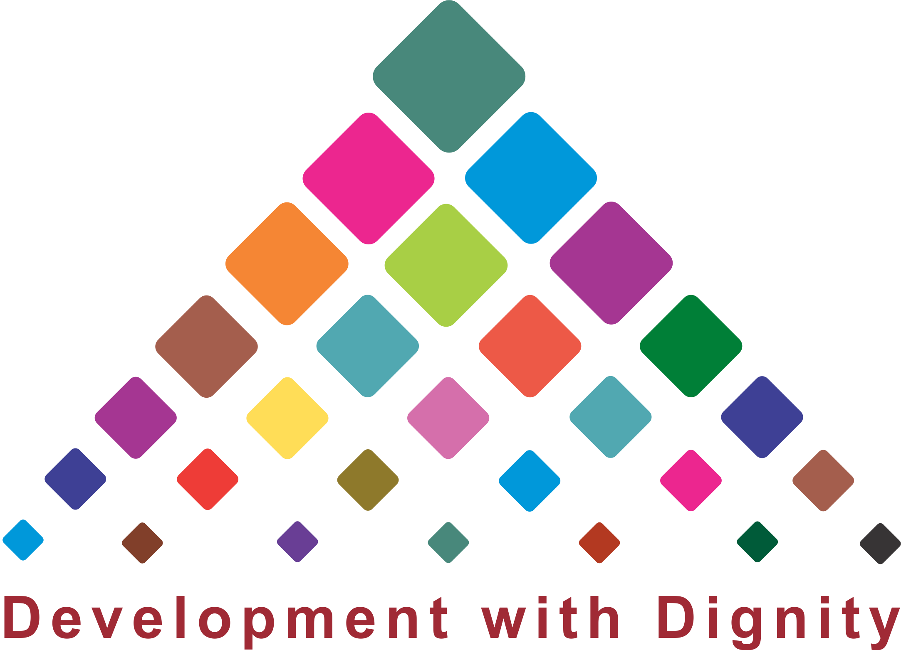
Microfinance and Inclusive Development
An Alternative Summit
June 21-23, 2011, Hyderabad, INDIA

BULLETIN

Development with Dignity

Hyderabad, June 21: “Being the home of SHG Movement, the State of Andhra Pradesh is at a very crucial juncture in the growth of microfinance. The first phase of microfinance has been over and we have seen a tremendous impact on the rural poor. The bigger challenge is how we are going to sustain it” said Sri Nallari Kirankumar Reddy, the Chief Minister of Andhra Pradesh at the inaugural session of three day international summit organised in Hyderabad. Delivering the inaugural address at the summit, he proclaimed that the state would continue to nurture the Movement by creating supportive environment and allocations to subsidise the interest that the SHGs are paying to bank at present. The SHGs were paid Rs. 750 crores towards interest subsidy, which made the women to get loans from banks at an interest rate of three percent per annum.
“In my home district Chittoor, where the dairy is a predominant activity, everyday 14 lakhs litres of milk is procured. Until our intervention the private dairies were making huge profits, they syndicated and fixed minimum price of Rs. 6 to 7 per litre which could not fetch any surplus to the farmers. We approached the NDDB for procurement and a cooperative arrangement was made to procure the milk through the producer groups” said the CM. “Today out of 14 lakhs litres, our SHGs procure 2.5 lakhs litres every day. They have planned to increase their procurement to 5.0 lakhs litres. The procurement price of milk has gone up to two to three times, not only for the SHG members, but also for the other farmers involved in dairy activity. This is an example a proactive initiative taken up by the IKP to benefit the poor communities” he claimed.
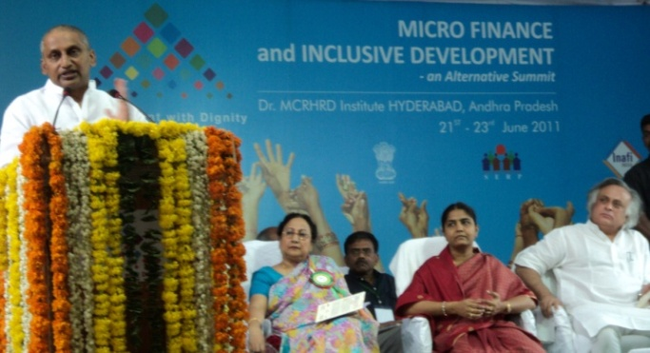
The impact of SHGs is not just on economic front alone. The poor women have gained confidence to face any situation and they have been empowered socially. This could be evident from the Government’s gesture to nominate a poor SHG woman - Srimathi Angoori Lakshmi Sivkumar as a Member of Legislative Council. Hereafter for representation of women for any forum, we would first look for members of Indira Kranthi Patham.
The International Network of Alternative Financial Institutions (INAFI) and the Society for Elimination of Rural Poverty (SERP), Government of Andhra Pradesh in association with the National Rural Livelihoods Mission (NRLM) of GoI is organising International Summit on the theme of “Microfinance and Inclusive Development” at Hyderabad from 21-23, June 2011. The Alternative Microfinance Summit would focus on sharing the knowledge and practice on advancing development with dignity for the poor communities. Microfinance practitioners from the countries such as Bangladesh, Philippines, Afghanistan, Nepal, Srilanka, Africa and USA are attending this Summit.

Sustainability is the Key
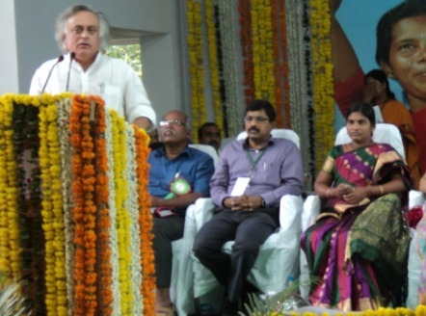
The Union Minister for Environment and Forests, Sri Jairam Ramaesh in his key note address congratulated the Andhra Pradesh government for championing the SHG model of microfinance. He distinguished the Indian SHG Bank linkage model with the traditional delivery model of microfinance through liability groups, pioneered by Prof. Mohammad Yunus of BRAC which focuses on credit and finance, whereas the Indian model is based on the Social Capital.
In the last two decades we had a phenomenal increase in the bank linked SHGs in our country. Unfortunately there is no reliable estimate of how many SHGs linked with banks. There are estimates ranging from 2.3 to 5 million bank linked SHGs in our country. It is happy to note that over 40 percent of all the credit issued to all the SHGs all over the country has been given to SHGs in Andhra Pradesh alone.
The entire world is looking at the Andhra Pradesh model. We need to study the sustainability of SHG model in Andhra Pradesh. I believe the single biggest challenge for the SHG Community is to make it financially sustainable. With roughly one million SHGs, 34000 Village Organisations, 1100 Mandal level Federations, it has been demonstrated that SHGs alone is not effective, when federated as Mandal Samakhyas, they are effective. This three pillar structure with Pavala Vatti, are the critical factors for the success. We must determine a threshold level in which the Mandal Samakhyas are financially sustainable independent of Government and government companies. When the Mandal Samakhya could generate a monthly income of Rs. 50,000, it can be classified as a sustainable institution. In my view about 50 percent of the Mandal Samakhyas are yet to become financially sustainable. Addressing the issue of financial sustainability is a bigger challenge.

Transforming Community Organisations
Sri. T. Vijay Kumar, Mission Director, NRLM
There are a lot of lessons to be learnt from the SHG experience in the states of Andhra Pradesh, Kerala, Tamil Nadu, Bihar and many other states, also in the other Asian countries where the SHG Movement has been rooted strongly. Thanks to the efforts of the States and NGOs for their contributions. There is no rigid guidelines to implement NRLM, each States can develop their own guidelines based on their experiences and they have been asked to prepare a seven year perspective document and also annual action plan for each State.
There are challenges to address at this point. Firstly the challenge of extreme poverty and poverty eradication in the extreme geography of this country, and how are we going to reach out to the poor. What are issues in scaling up programmes?
Secondly the institutions of the poor, the community based organisations are critical for the poverty reduction. These Peoples Organsiations are catalysed by the Government and NGOs, the challenge is how the relationship between the CBOs and promoting organisations going to change. In one side there is a proactive States that nurtures the SHG Movement and on the other side hardly there is any presence of Government in this issue. How are we going to address this imbalance and what should be and should not be the role of the government in nurturing the Movement.
We should demonstrate that the CBOs are holistic and not just providing financial services. We will have to work on livelihood based organisations and livelihood promotion, which is an issues for the next generation SHGs and organisations. Finally, the risk management, what are the best practices in risk management and how are we going to learn from others’ experiences.
Because of the cut throat commercial tactics of a few Microfinance Institutions we should not condemn the entire Microfinance industry. I support the view that microfinance needs regulation. Even the Malegam Committee appointed by the Reserve Bank of India recommended the need for such regulation. If the MFIs involved in social capital formation we would not have found any problem with them, whereas the MFIs are primarily focusing on mobilising share capital, profits, foreign investment, and not concerned about the social capital, we are finding an issue. While I entirely endorse the regulation that was brought out by the Andhra Pradesh Government, I request the State Government to follow the innovations of the MFIs in terms of the nature of the products and timing of the product, also offer it with Pavala Vatti, and then allow the market to reject the MFIs. Through this summit we should re-establish the image of microfinance as not just a solution, but a supplement to the mainstream efforts for poverty alleviation.
Inclusiveness or inclusive development is much misunderstood subject in our country and all over the world. It is a complex subject, it requires first of all inclusive thinking. Inclusiveness is not just finance alone; it has social, political, cultural and ecological implications. Therefore the inclusive development is not a consequence of growth or development; it is a process of growth and development. Building SHG Movement and convergence of development programmes with SHGs are extremely important for bringing inclusive development. Also inclusive development cannot be centrally administered and monitored as some of the States trying to do. The tendency is that microfinance is a universal solution for all the problems. Nine states in India are performing badly in Multi Dimensional Human Development Indicators, despite their intensive work in SHG Movement. It needs a for multi dimensional approach to tackle the issue of Human Development.
Sri. Yugandhar, IAS (Retd.)
PLENARY SESSION

M.P. Vasimalai, Executive Director, DHAN Foundation
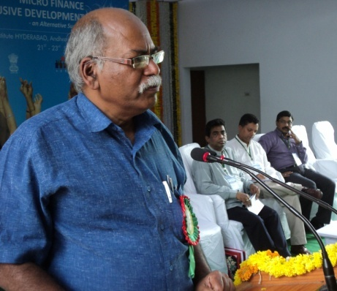
Microfinance should focus on enlarging the choices and opportunities of the clients rather than on a mechanical delivery mode or a supply driven. It has to be redefined from the perspective of clients that promotes and enhances the social capital, the leadership of the clients. In other words taking charge of the microfinance by clients themselves.
The microfinance eco system which builds social capital has a greater potential to create and nurture specialised people institutions to offer specialised products like social security. Stressing the holistic development through microfinance he emphasised four generation approach starting with social intermediation, financial intermediation, livelihood intermediation and civic intermediation. Interestingly the practitioners have begun to realise the space being provide by the microfinance to localise MDGs with context specific target and indicators. Towards this end, State, Banks, academia, market and people institutions have to have the greater appreciation and sensitization. Calling for greater integration of microfinance with other development programmes including livelihoods, climate change adaptation, the need for long term engagement cannot be over emphasised.
Sri. Shakila Wijewardena, SEEDS, Srilanka
Microfinance should ultimately lead to self reliance. Microfinance institutions whatever may be the typology- village banks, SHGs, larger groups, etc need to focus on good governance and non financial capital (social capital) and the financial capital need to be judiciously integrated with the operations.
Mr Zakir Hossain, BURO, Bangladesh
Financial inclusion is a matter of creating equal opportunity, which enhances choices. The poor do not want charity, they want access and opportunity for financial capital to become self reliant on their own. This will bring about development with dignity.

Ruth Mamerta Callanta, Philippines
She emphasised on the critical importance of the capacity building in running microfinance clients both for the clients and the civil society. As has been evident from the experiences, Microfinance per se could not be effective for holistic development, which needs to be an integral part of the integrated poverty eradication measures. All these works, in the ultimate analysis should lead into empowerment of the marginalized.
PARALLEL SESSIONS
Social Inclusion and Inclusive Development
- Microfinance as a development instrument has proved its usefulness for building social capital in reaching out to the poor and also the other excluded population such as, poorest of the poor, aged, destitute women.
- Highly vulnerable groups are to be organised with the help of microfinance exclusively with higher degree of sensitivity and innovation.
- For promoting and expanding social capital model, which advances social inclusion process shall have the greater support of the public funds.
Livelihood system and value chain approach
- The approach to build value and supply chain begins with mapping out economic sub sector with focus and identified intervention points including market linkage.
- Capacity building is the key element of the value-supply chain approach.
- Value-supply chain needs public investment for creating infrastructure like cold chain, transport, processing, etc through public investment.
- Community ownership in the form of producer and marketing companies with professional management should be the way forward.
Legal and governance issues
- There is a need for laying down governance norms widely shared across members, and clearly internalised by all.
- Leadership being the crucial component of governance, which needs to be focused in microfinance interventions through the process of nurturing and mentoring.
- Mutuality based community organisations fulfilling definite criteria should be exempted from service tax and income taxes.

Building Demand Stream – SHG Federations
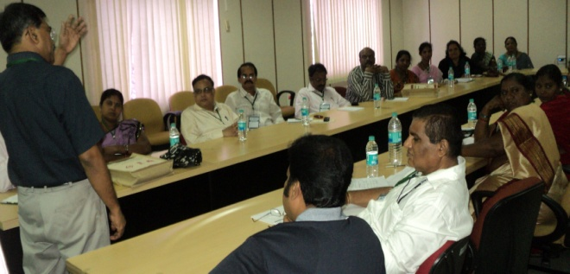
- Building a strong demand stream in the form of SHG Federations is critical for creating access to resources and control over the issues affecting their lives.
- The SHG Federations provides social safety-nets to the vulnerable communities and creates opportunity for them to negotiate with the mainstream to claim their entitlements.
- The social capital built by the SHG Federations should be converted into financial capital, as both are critical for achieving self reliance and sustainability.
Special Purpose Peoples’ Institutions
- The issues of poverty have different dimensions, forms and are highly contextual. It necessitates creation of specialised Peoples’ Institutions to address specific needs like social security.
- Special purpose peoples’ institutions are necessary to deepen the microfinance services.
Tribal Livelihoods
- Tribal economy is mostly non-monetized or semi-monetized economy. Tribal livelihoods are primarily based on access to forest, availability of land and water resources. Microfinance interventions should focus on creating access and enhance performance of such assets.
- Promotion of horticulture would help conversion of underutilized and degraded land to productive asset for the tribal households, and it can reverse migration to a greater extent.
- The social capital mobilized among the tribal communities through the microfinance interventions could be a driver of change, which can help them bargain collectively for protecting their rights on land and forests.
Farm based livelihoods
- The second generation SHG Federations should be grouped into commodity clusters later transform into producer and marketing companies and they should identify intervention points that would eliminate middlemen and maximize return for the farmers.
- Need based and context specific insurance products to protect the famers from crop/yield loss due to natural disasters, credit products responsive to the needs of farmers at an appropriate time are critical for ensuring livelihood security.
- There should be a public investment in creation of infrastructures for value addition and storage to cope up with the dynamic market situation.
- Creation of technical and financial linkages with relevant institutions would help the farmers to enhance their production and productivity.
Coastal Livelihoods
- Livelihood opportunities for fishers needs long term strategy, with a focus on fishery resource management, income diversification and capacity building.
- The NGOs to play the role of facilitators and they should use microfinance as a tool for organizing the coastal communities, enabling them to get prepared to face disasters, evolve needs based social security products to fishers.
Self Regulation
- Self-regulation is a value, which encompasses evolving goals, and practising norms and policies by the SHG Federations themselves for the development of their members without compulsion from external forces. Self-regulation nurtures and moulds the self-discipline of individuals, groups, communities and society.
- Each SHG Federation should draw a road map and set standards for governance, financial and social development aspects according to their age and contexts and evolve action plans for implementation.
The Community Resolution on the issues of MFIs
We, the women representatives of SHGs in Andhra Pradesh met at the Summit and deliberated upon the issues of MFIs and resolved to condemn the exploitative practices of profit centric MFIs, who is charging exorbitant rates of interest and often violating human rights at times of recovery with coercive methods. We are proud to claim that the SHG Model of microfinance spearheaded by the poor women is appropriate to our needs and it would help tackle the issues of poverty.
  National Rural  Livelihoods Mission |  | 